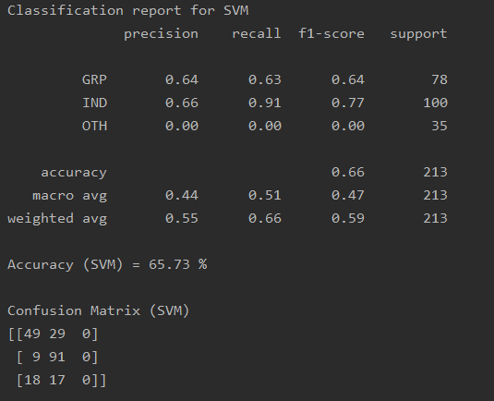

Classification report for SVM

precision recall f1-score support

GRP 0.64 0.63 0.64 78

IND 0.66 0.91 0.77 100

OTH 0.00 0.00 0.00 35

accuracy 0.66 213

macro avg 0.44 0.51 0.47 213

weighted avg 0.55 0.66 0.59 213

Accuracy (SVM) = 65.73 %

Confusion Matrix (SVM)

[[49 29 0]

[ 9 91 0]

[18 17 0]]

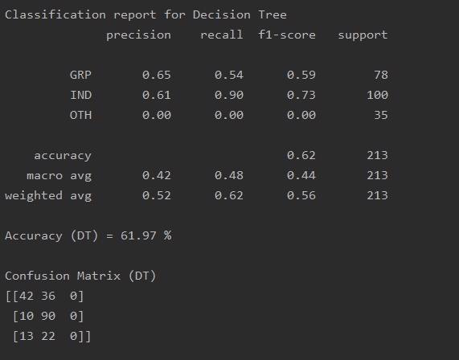

Classification report for Decision Tree

precision recall f1-score support

GRP 0.65 0.54 0.59 78

IND 0.61 0.90 0.73 100

OTH 0.00 0.00 0.00 35

accuracy 0.62 213

macro avg 0.42 0.48 0.44 213

weighted avg 0.52 0.62 0.56 213

Accuracy (DT) = 61.97 %

Confusion Matrix (DT)

[[42 36 0]

[10 90 0]

[13 22 0]]

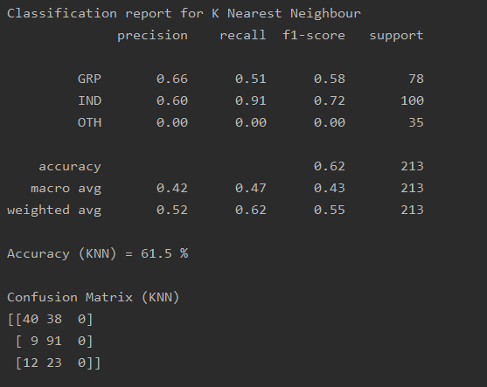

Classification report for K Nearest Neighbour

precision recall f1-score support

GRP 0.66 0.51 0.58 78

IND 0.60 0.91 0.72 100

OTH 0.00 0.00 0.00 35

accuracy 0.62 213

macro avg 0.42 0.47 0.43 213

weighted avg 0.52 0.62 0.55 213

Accuracy (KNN) = 61.5 %

Confusion Matrix (KNN)

[[40 38 0]

[ 9 91 0]

[12 23 0]]

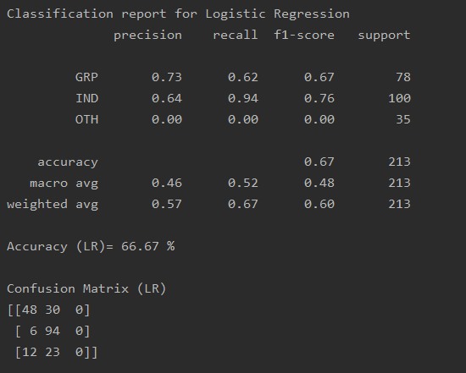

Classification report for Logistic Regression

precision recall f1-score support

GRP 0.73 0.62 0.67 78

IND 0.64 0.94 0.76 100

OTH 0.00 0.00 0.00 35

accuracy 0.67 213

macro avg 0.46 0.52 0.48 213

weighted avg 0.57 0.67 0.60 213

Accuracy (LR)= 66.67 %

Confusion Matrix (LR)

[[48 30 0]

[ 6 94 0]

[12 23 0]]